**Special Valuation Branch (SVB) Flowchart-**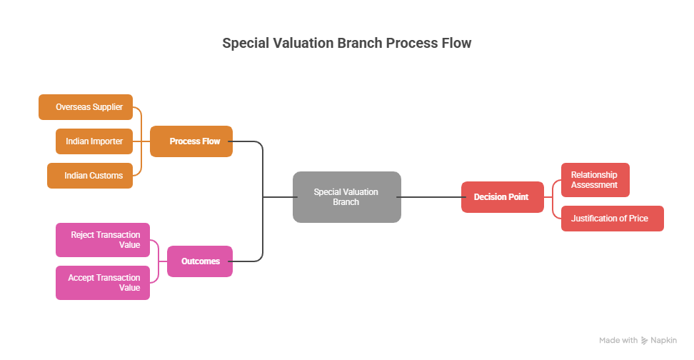

Content 1:

**Customs Process for Related-Party Import & SVB Till IR Issue**

1. Importer Files Bill of Entry (BE)

⬇

2. Customs Identifies Related Party Transaction

* Relationship under Rule 2(2) of Customs Valuation Rules, 2007
* OR special circumstances (royalty, technical know-how, etc.)

⬇

3. Provisional Assessment

* Assessment under Section 18 of Customs Act
* Bank Guarantee & Bond (usually 1%–5% of assessable value or as directed)

⬇

4. Direction to Approach SVB

* Importer is directed to file Annexure A (application) with SVB
* Submission of agreements, pricing policies, financials, etc.

⬇

5. Acknowledgment & File Number

* SVB registers the case & issues a case reference

⬇

6. Submission of Documents

* Importer submits:
  + Annexure B (detailed questionnaire)
  + Transfer pricing documents (if any)
  + Inter-company agreements, royalty/commission details, etc.

⬇

7. SVB Examination

* Officer reviews documents, transaction pricing, and relationship impact
* May ask for additional clarifications

⬇

8. Hearing & Representation

* Importer may attend hearings & provide justifications

⬇

9. Draft Findings & Discussions

* SVB prepares draft observations

⬇

10. Issue of SVB Investigation Report (IR)

* Investigation report issued to the Appraising Group
* Assessment finalized based on findings